**Assignment -1**

Flask Programming

|  |  |
| --- | --- |
| Assignment Date | 14 September 2022 |
| Student Name | Mr. M.Krishnaraj |
| Student Roll Number | 814619104011 |
| Maximum Marks | 2 Marks |

**Question-1:**

Write a flask program which should display Name, Email, Phone and it should display the same details once we hit submit.

**Solution:**

from flask import Flask, redirect,url_for, request,render_template,json

import os

app = Flask(__name__)

team_member2 = {“1” : “KRISHNARAJ M”,”2” : “krishnarajgunal@gmail.com”, “3” : “+912344378911”}

@app.route(‘/data’, methods = [‘POST’,’GET’])

def api():

if request.method == ‘GET’:

return team_member2

if request.method == ‘POST’:

data = request.json

team_member2.update(data)

return “Data is inserted”

@app.route(“/data/<id>”, methods=[“PUT”])

def update(id):

data = request.form[‘member’]

team_member2 [str(id)]=data

return “Data is updated”

@app.route(“/data/<id>”, methods=[“DELETE”])

def delete(id):

team_member2.pop(str(id))

return “Data Deleted”

if __name__ == ‘__main__’:

port = os.environ.get(‘FLASK_PORT’) or 8080

port = int(port)

app.run(port=port,host=’0.0.0.0’)

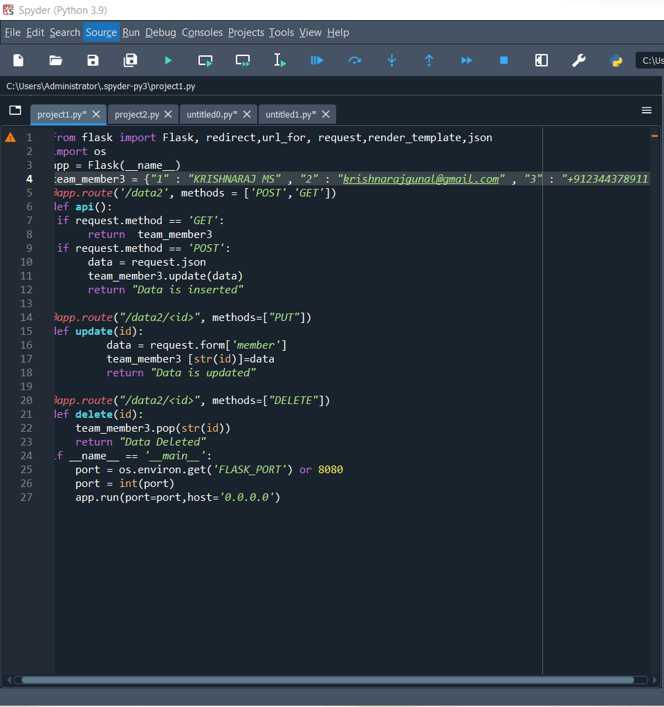

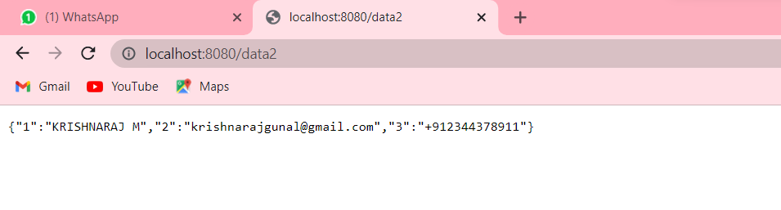

**Question-2:**

**Write a flask program which should cover cookies and session.**

**Solution:**

### **Create cookie**

@app.route(‘/’)

Def index():

Return render_template(‘index.html’)

**This HTML page contains a text input.**

<html>

<body>

<form action = “/setcookie” method = “POST”>

<p><h3>Enter userID</h3></p>

<p><input type = ‘text’ name = ‘nm’/></p>

<p><input type = ‘submit’ value = ‘Login’/></p>

</form>

</body>

</html>

**Set cookie**

@app.route(‘/setcookie’, methods = [‘POST’, ‘GET’])

Def setcookie():

If request.method == ‘POST’:

User = request.form[‘nm’]

Resp = make_response(render_template(‘readcookie.html’))

Resp.set_cookie(‘userID’, user)

Return resp

### Get cookie

### @app.route(‘/getcookie’)

Def getcookie():

Name = request.cookies.get(‘userID’)

Return ‘<h1>welcome ‘ + name + ‘</h1>'

**Output**

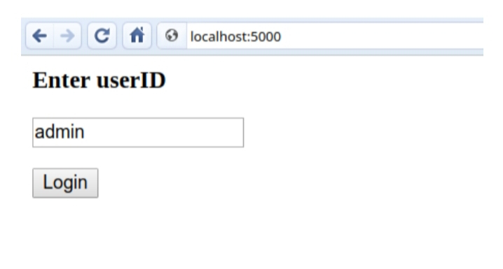

**SESSION**

From flask import Flask, render_template_string, request, session, redirect, url_for

@app.route(‘/set_email’, methods=[‘GET’, ‘POST’])

Def set_email():

If request # Create the Flask application

App = Flask(__name__)

App.secret_key = ‘BAD_SECRET_KEY’

.method == ‘POST’:

# Save the form data to the session object

Session[‘email’] = request.form[‘email_address’]

Return redirect(url_for(‘get_email’))

Return “””

<form method=”post”>

<label for=”email”>Enter your email address:</label>

<input type=”email” id=”email” name=”email_address” required />

<button type=”submit”>Submit</button

</form>

“””

@app.route(‘/get_email’)

Def get_email():

Return render_template_string(“””

{% if session[‘email’] %}

<h1>Welcome {{ session[‘email’] }}!</h1>

{% else %}

<h1>Welcome! Please enter your email <a href=”{{ url_for(‘set_email’) }}”>here.</a></h1>

{% endif %}

“””)

@app.route(‘/delete_email’)

Def delete_email():

# Clear the email stored in the session objects

Session.pop(‘email’, default=None)

Return ‘<h1>Session deleted!</h1>’

If __name__ == ‘__main__’:

App.run()

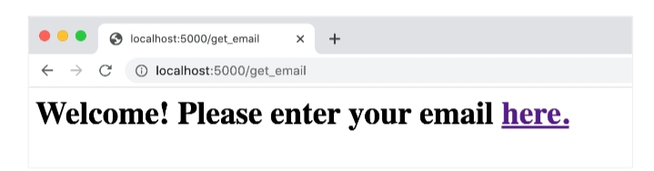

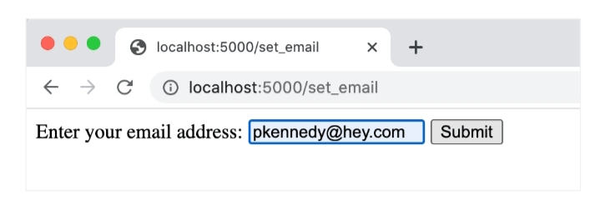

**Question-3:**

**Write a flask program which should display resume details and also have upload resume option by using file uploading.**

**Solution:**

Upload file html program:

<html>  
 <body>  
 <form action = "http://localhost:5000/uploader" method = "POST"   
 enctype = "multipart/form-data">  
 <input type = "file" name = "file" />  
 <input type = "submit"/>  
 </form>   
 </body>  
</html>

**Flask program:**

from flask import Flask, render_template, request  
from werkzeug import secure_filename  
app = Flask(__name__)  
  
@app.route('/upload')  
def upload_file():  
 return render_template('upload.html')  
   
@app.route('/uploader', methods = ['GET', 'POST'])  
def upload_file():  
 if request.method == 'POST':  
 f = request.files['file']  
 f.save(secure_filename(f.filename))  
 return 'file uploaded successfully'  
   
if __name__ == '__main__':  
 app.run(debug = True)

